CTIS 256
Midterm 1
Duration: 110 minutes
Question 2 (50Pts):
Write a sticky web form that allows a user to configure a Samsung phone and calculates the final price.
There are three models: Samsung S25 Ultra, Samsung S25 Edge, and Samsung S25+. Their base prices for 256GB are 70,000 TL, 65,000 TL, and 50,000 TL respectively. If the user selects 512GB, the base price is multiplied by 1.10; if 1TB is selected, it is multiplied by 1.25. If Shipping is selected, add 500 TL to the total price. The user also enters the Units value, and the total price is calculated accordingly. The result should be displayed as in Fig. 2.
The form must be sticky, meaning all selected values remain after submission.
Validation: Validate Units and Storage. The Units field must be a positive integer; otherwise display “Error: Unit should be an integer number”. If Storage is not selected, display “Error: Select a storage”. Error messages should appear at the bottom of the page, in red and italic.
Watch q2.mp4 to see the expected behavior.

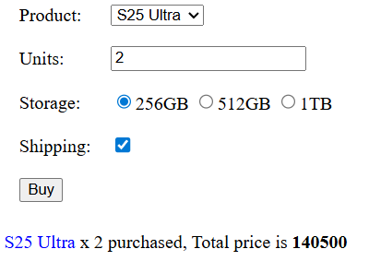
Fig 2 : Total price

Grading:
- (5Pts) HTML Web Form
- (10Pts) Display Phone name and quantity in the output
- (10Pts) Calculate and display the total price
- (10Pts) Sticky web form
- (15Pts) Input Validation
- Good Luck -

